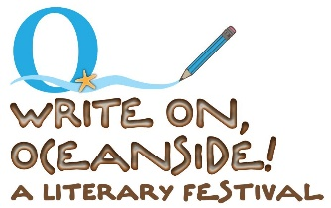
Saturday, August 28 from 10 a.m. to 2 p.m.
Civic Center Plaza and Courtyard at 330 N. Coast Highway

Please join us for the 11th Annual FREE Literary Festival!

SCHEDULE of EVENTS:

10 a.m. Author Bookfair and Introductions:
The Community will have the chance to meet local authors and hear them speak about their books/writings. Books will be for purchase and Signing!

11 a.m. Children’s Storytime and Crafts:
Illustrator Linda Kallas will read Mel and the Blue Arrow, the true story of an event in the life of Luiseño boy who spent time at his grandfather’s ranch in the San Luis Rey Valley.
Linda will have a special craft after the story (appropriate for 5-10 years old)

1 p.m. Writers' Open Mic:
Local writers--published or not--will have the chance to share their writings. Only 12 spaces available, so sign up EARLY!

Ongoing- Never-ending Story:
Everyone is invited to try their hand at adding to the NeverEnding Story by writing a line or two.

Online at 3p.m.
Special presentation OF All Sides of Oceanside Writing and Video Challenge
Register for link: SEND AN EMAIL TO oceansidelibrary@gmail.com

Thank you to Our Sponsors:

