SAVE THE DATE
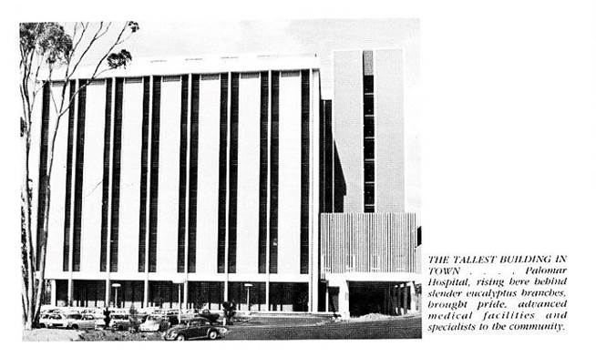
Integral Communities’ Palomar Heights - Demolition Day Event
August 6, 2021

The tallest building in town is being torn down! Join Integral Communities and members from Escondido’s business community as we mark the first milestone of the new Palomar Heights community. We will be hosting a brief, early morning “Croissants and Cranes” celebration as we commence demolition of the historic old Palomar Hospital.

Time and Location: 8 a.m. – 9:30 a.m. West Grand Avenue, Escondido (It’s the grassy corner of Valley Boulevard. and Grand Avenue. For directions use 555 E Valley Pkwy, Escondido, CA 92025.)

Integral Communities proudly introduces Palomar Heights, an urban lifestyle community situated at the eastern gateway of Escondido’s historic downtown in the location of the Old Palomar Health Hospital. The new development will feature 510 apartments and townhomes, a retail farmer’s market, restaurants, and collaborative work spaces, bringing new residents and vibrancy to downtown Escondido. The project will revitalize the former downtown health campus and transform it into a thriving commercial and residential city hub.

Please contact Christine Rombouts, 949.631.1557 / crombouts@newgroundco.com. We hope to see you there! This is big news!

