Word Count: 360

San Diego Region is Drought-Safe This Summer
Residents asked to voluntarily keep using water efficiently
Strategic investments and water-use efficiency mean no shortages or mandates in forecast
Statewide drought conditions are highlighting the value of regionally and locally controlled water supplies in San Diego County, where the San Diego County Water Authority has announced that the region is protected from drought impacts this summer, and through 2045, despite continued hot and dry conditions.
No shortages or regional water-use mandates are in the forecast, the result of three decades of strategic investments that create an aquatic safety net for San Diego County’s $253 billion economy and quality of life for 3.3 million residents. In fact, a recent Wall Street Journal article highlighted the role of San Diego’s regional water supply portfolio of investments in protecting the economy from drought.
“Thank you to San Diegans for everything you have done to make sure that we have enough water to meet the region’s needs now and for decades into the future,” said Gary Croucher, Water Authority Board Chair. “You have invested through your water bills and your water-smart practices, and those efforts are paying off in tangible ways. The key this summer is to stay water-smart. You can find tips, rebates and landscape class information at https://www.sdcwa.org/your-water/conservation/ .”
In the early 1990s, the county’s economy was crippled by drought, suffering 13 straight months of 31% supply cutbacks from the Water Authority’s wholesale water provider. At the time, the Los Angeles-based Metropolitan Water District of Southern California controlled almost all of San Diego County’s water supplies.
Today, the picture is much different: The region’s diversified water supply portfolio includes highly reliable, locally controlled and drought-proof supplies from the Claude “Bud” Lewis Carlsbad Desalination Plant and the nation’s largest water conservation-and-transfer agreement, which provides high-priority, low-cost water from the Colorado River. The combination offers significant protection against droughts and other emergencies so that the Water Authority’s 2020 Urban Water Management Plan shows San Diego County will continue to have sufficient water supplies through the 2045 planning horizon, even during multiple dry years.
“Our region’s economy and quality of life is brought to you by water,” said Croucher. “The Water Authority and its 24 member agencies are committed to providing the fundamental water resources that keep the region strong – not just for today, but for the long-haul.”
For more information about water supplies in the San Diego region, go to https://bit.ly/InvestmentsProtectRegion.

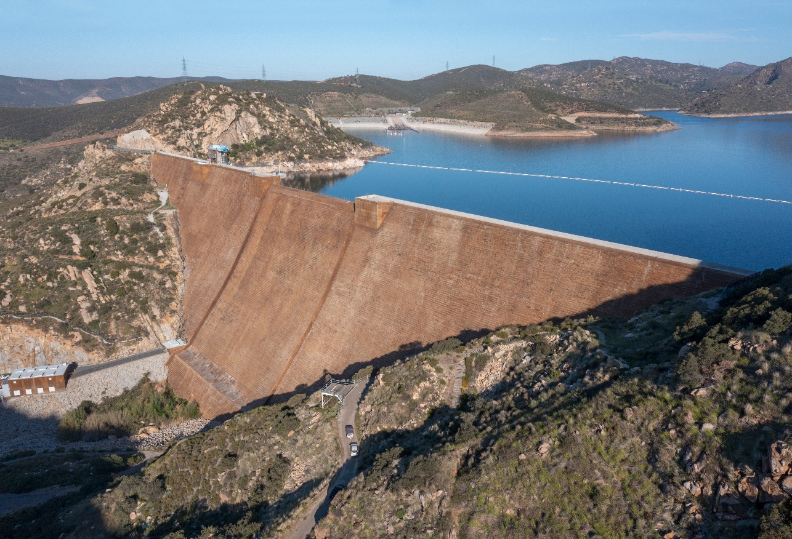
Caption: Strategic infrastructure investments, such as the San Vicente Dam, help provide an
aquatic safety net in times of drought.

